Guivolviewih Documentation
16th January 2003
Ian Hopkinson
Modifications:

Summary
Guivolviewih is a Matlab program, including a graphical interface, designed to assist in the analysis of compressed emulsion data. The program takes confocal image files as one input and ‘droplet’ files from variants of the calcDroplets program as its other input and displays the found droplets as an overlay on the image file. Multiple droplet files can be loaded together and the resulting list can be amended by the interactive addition of new droplets and the deletion of incorrect or ‘repeated’ droplets, the amended list can then be saved. Droplet properties (index number, x, y, z and r) can easily be extracted for any droplet by a single mouse click. In principle the program could be used to unify analysis procedures – there is no reason why calcDroplets and calcRealForces, for example, cannot be called from guivolviewih.

Operation
To run guivolview ensure that the files listed in the Requirements section are in the Matlab path (or in the current directory) then type:
>>guivolviewih_export
You should be faced with a window which looks like figure 1
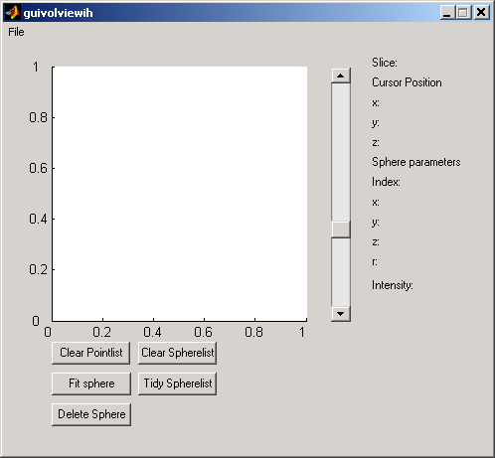
Figure 1

Menu Items
The drop-down file menu has the following items:
(1) Open Image File…this is used to open up a confocal image file either a tif stack or a native .mat file (which loads more quickly). A file dialog will ask for ‘zsp’ which is a xz aspect ratio – 2.16 for the big new data file and 1.33 for the old file. The data is displayed in the window – you can navigate up and down the slices using the slider – the slice number will be displayed in the corner. The image is downsized to 256x256.
(2) Open Droplet File…this will load up a droplet file output from one of the calcDroplets programs, either a .mat format file or a .txt – I have always used the hand filtered .txt files. The data are stored in the ‘spherelist’ You can load multiple droplet files, as a default all of the droplets in all of the files are combined together. See below for ways of processing this list.
(3) Save Droplet File…this will prompt for a file name to save a processed droplet list. The droplet file can be reloaded into guivolviewih and it should also be compatible with calcRealForces.
(4) Close – you can guess what this does – no warning if you are about to lose work.

Mouse action
The mouse has the following action:
Clicking the mouse on the image will create a point on the image whose coordinates are stored in a ‘pointlist’ and displayed in the top right beneath the ‘Cursor Position’ label; if the point selected falls within a droplet then the details will appear below the ‘Sphere Parameters’ label. If the selected point lies within more than one sphere then the properties of all the spheres will be displayed in the Matlab command window.

Buttons
The buttons carry out the following functions:
(1) Clear Pointlist – this will clear the current ‘pointlist’, generated by clicking on the image. You will want to use this before you start selecting points to do a ‘Fit sphere’
(2) Clear Spherelist – this will clear the ‘spherelist’
(3) Fit Sphere – this will take the current ‘pointlist’ and fit a sphere to it. I normally select 3 points on a candidate sphere from one slice and then go up or down as many slices as I can and select another couple of points. After you’ve done the fit the details will appear in the Matlab command window and the newly fitted sphere will be overlaid on the image. The ‘pointlist’ is kept. If the fitted sphere looks crap then you probably didn’t clear the ‘pointlist’ before you started selecting points for a fit. The fitted spheres have their intensity set to 1.0 – whilst spheres from calcDroplets have intensities <<1.
(4) Tidy Spherelist – this merges spheres with similar centre positions and deletes entries in the ‘spherelist’ which read 0,0,0,0 – i.e. ones that have been deleted. You should do a tidy before saving a droplet file. The merge algorithm is a bit crude, it assumes that the spheres with close centres are all pretty much the same and pretty good.
(5) Delete Sphere – this will ask for the ‘index’ of the sphere to be deleted. The entry in the ‘spherelist’ is set to 0,0,0,0 – using ‘Tidy spherelist’ will remove this ‘null’ entry.

Implementation Notes
The program was written using Matlab 6.5 (R13), this is pretty similar to Matlab 6.1 (R12), however Matlab 6.5 separates gui’s into two files one containing the function calls (guivolviewih.m) and one containing the instructions for building the gui (guivolviewih.fig). To produce a version which runs on Matlab 6.1 the gui is exported from GUIDE, this produces a single merged file (guivolviewih_export.m).
There are a few minor differences in Matlab between versions 6.1 and 6.5 but the intention is to write in a style compatible with version 6.1. Differences discovered so far:
(1) 6.5 supports &&, 6.1 doesn’t - & works just as well.
(2) 6.5 returns and index value from the functions uigetfile and uiputfile, 6.1 doesn’t – avoid this problem by using fileparts.
(3) 6.5 allows the construct droplets=tmp.(names{1,1}), 6.1 doesn’t - droplets=getfield(tmp, names{1}) is equivalent.

To do
-Algorithm for Clean Spherelist is a bit simple.
-Probably won’t work if droplet data from a run which wasn’t ‘downsized’ was used.

Requirements
Matlab 6.1 (R12)
Guivolviewih_export.m
sphfunc.m
spherefit.m
cirwhich.m
cirpaint2.m

